CDS 3300: Statistical Inference and Modelling in R
Chapter 1: Introduction
Statistical inference in R involves concluding a population from a sample using probability theory, including techniques such as hypothesis testing, confidence intervals, and parameter estimation. Statistical modelling in R refers to fitting mathematical models (e.g., linear regression, ANOVA, GLMs) to data to describe relationships between variables and make predictions. Together, they form the core of data-driven decision-making in R, supported by functions like lm(), glm(), t.test(), and packages such as stats and MASS.
1.1 Definitions.
R- R is a free, open-source programming language and software environment specifically designed for statistical computing, data analysis, and graphical visualisation. It compiles and runs on a wide variety of UNIX platforms, Windows and macOS. The software is available for free from the website link: https://www.r-project.org/
Task 1: Download and install R on your computer from the indicated website.
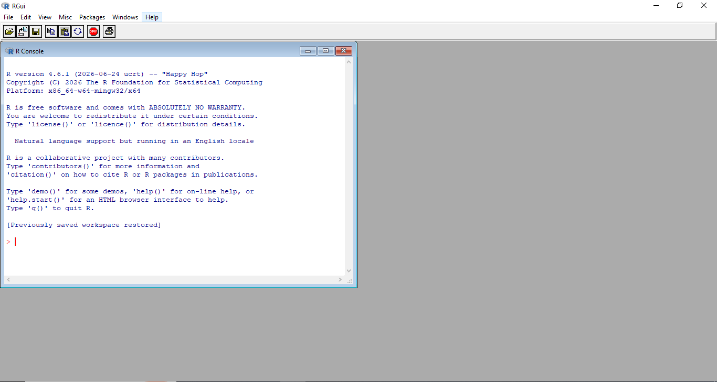
Figure 1: R-window Screenshot
RStudio: RStudio is a free, open-source integrated development environment (IDE) that provides a user-friendly interface for writing and running R code, with features like a code editor, console, workspace viewer, and plot pane. The software is available at this link: posit.co/downloads/
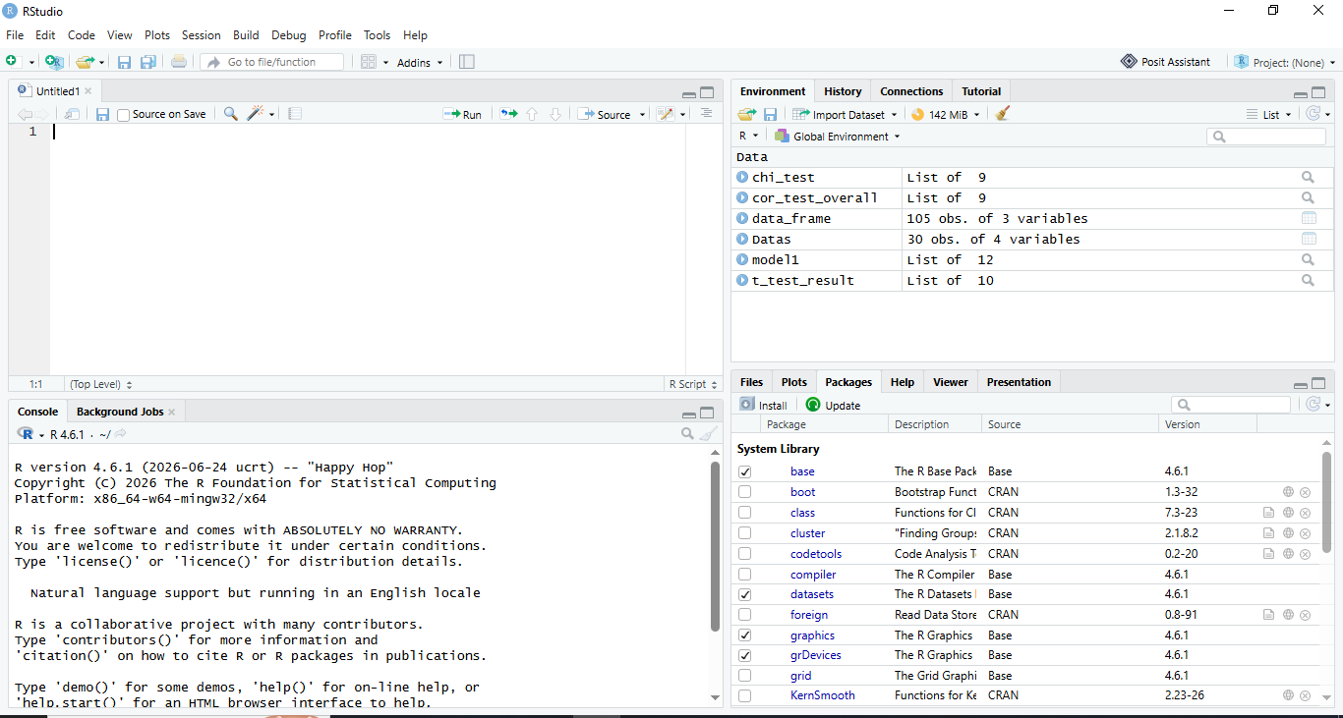
Figure 2: R-studio Window
An IDE (Integrated Development Environment) in the R context is a software application that combines a code editor, console, debugger, and visualisation tools into a single interface to streamline R programming and data analysis.
Task 2: Download and install R on your computer from the indicated website.
1.2: Importance of Data-Driven Decisions
Enhanced Customer Understanding: By analysing customer behaviour, preferences, and feedback, businesses can tailor products and services to better meet market demands
Operational Efficiency: Data analysis helps identify inefficiencies in processes, optimise resource allocation, and improve overall operational performance
Risk Mitigation: Statistical analysis allows organisations to quantify and manage risks more effectively, particularly in fields like finance and healthcare
Innovation and Development: Data-driven insights can reveal new opportunities for innovation, product development, and market expansion.
1.3 Real-World Applications
Data analysis with R has been successfully applied across diverse domains:
Clinical Trials: In medical research, statistical analysis is used to determine the effectiveness of new treatments or interventions. Researchers use statistical methods to compare treatment groups, assess the significance of results, and make inferences about the broader population of patients
Quality Control: In manufacturing and industrial settings, statistical methods are employed to monitor and improve product quality. Techniques such as hypothesis testing and control charts help make inferences about the consistency and reliability of production processes
Finance and Insurance: R is used for risk analysis, portfolio management, and actuarial modelling. Statistical inference helps in assessing credit risk, predicting market trends, and determining insurance premiums
Marketing Research: Businesses use statistical techniques to analyze consumer behavior, conduct surveys, and make predictions about market trends. This includes customer segmentation, conjoint analysis, and effectiveness measurement of marketing strategies.
1.3 RStudio Layout (The IDE)
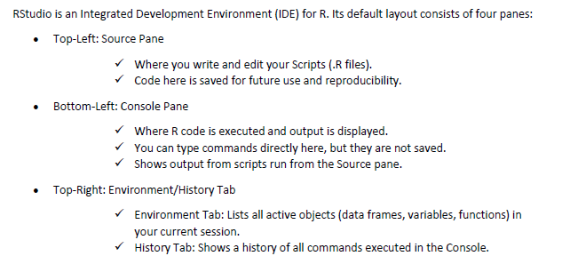
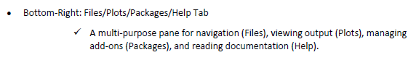
Note: 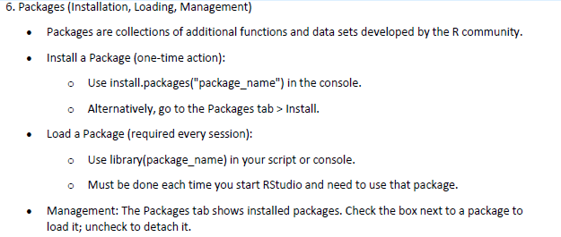
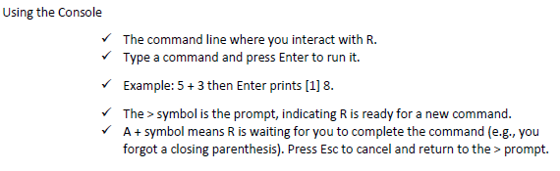
Task 3: Write brief notes on R Markdown

